
Project Report Template

- INTRODUCTION 1.1 Overview

- The project aim is to provide real-time knowledge for all the students who have basic knowledge of Salesforce and Looking for a real-time project. With the help of this project they will gain knowledge and can include it into their resume as well.
1.2 Purpose

We will learn
- 1.Real Time Salesforce Project
- 2.Object & Relationship in Salesforce
- 3.Profile
- 4.Users
- 5.Reports
- 6.Permission sets
- 7.Reports
.

- Problem Definition & Design Thinking

2.1 Empathy Map
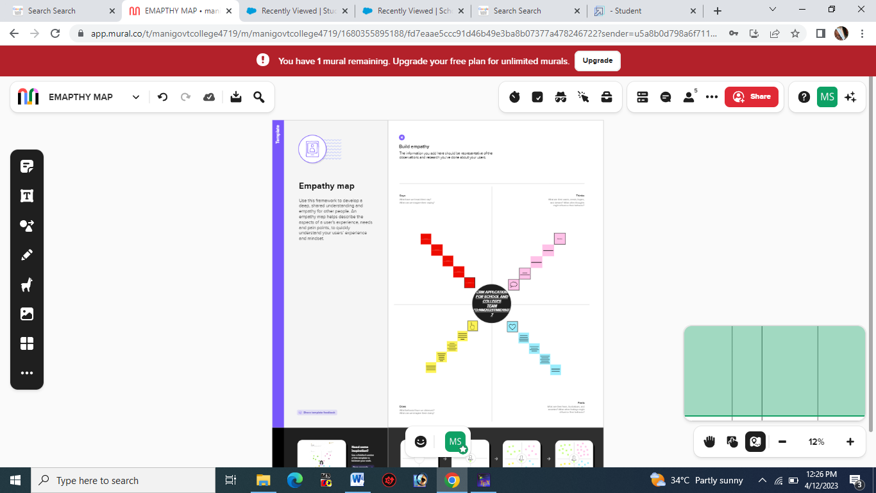

2.2 Ideation & Brainstorming Map
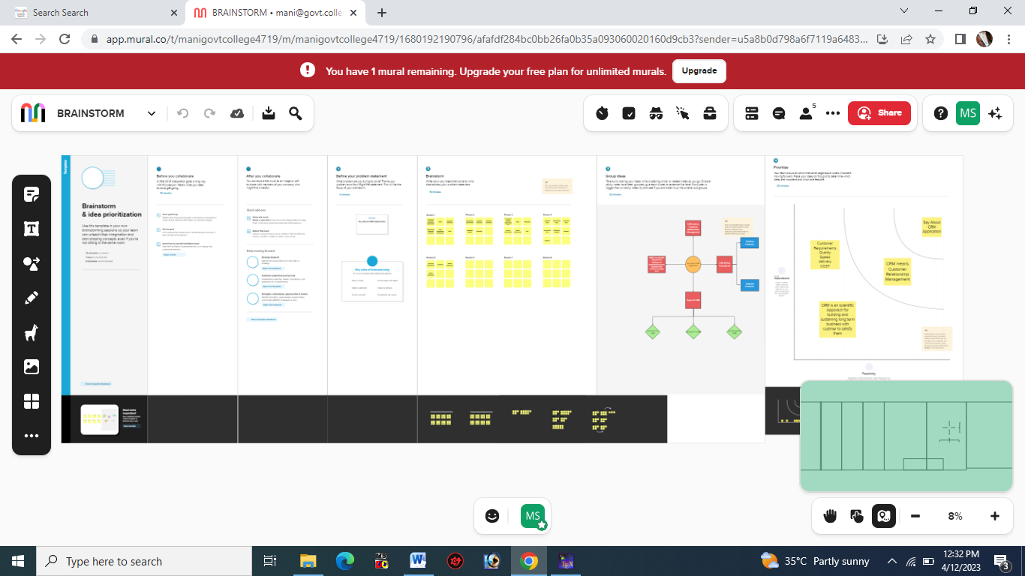

- RESULT

3.1 Data Model:

Object name |  | Fields in the Object
obj1
 |  |  | Field label | Data type
 |  |  | School
obj2
 |  |  | Field label | Data type
 |  |  | Student
Obj3
  Field lable | Data type
  Parents

3.2 Activity & Screenshot
Milestone-2:Object
Student Object

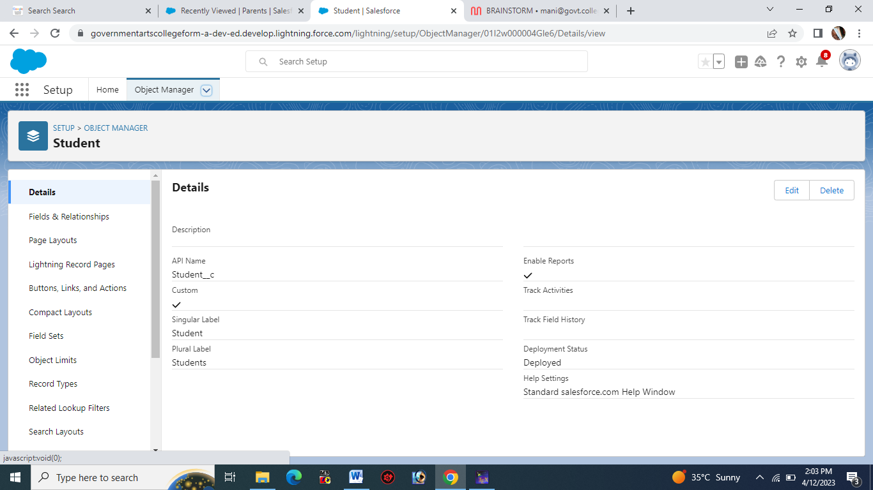
School Object
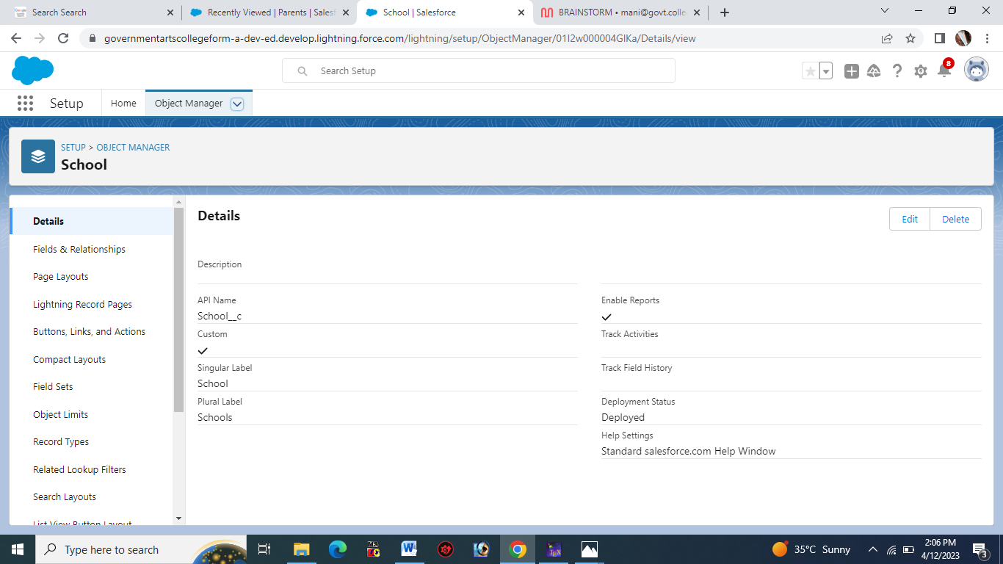
Parent Object
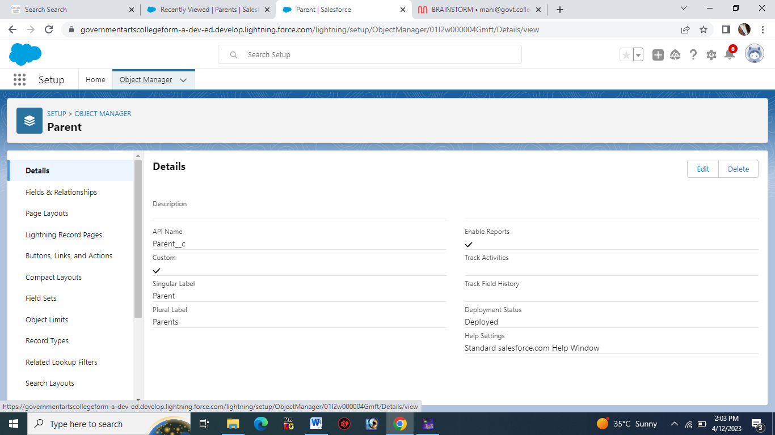

Milestone-3: Lightning App
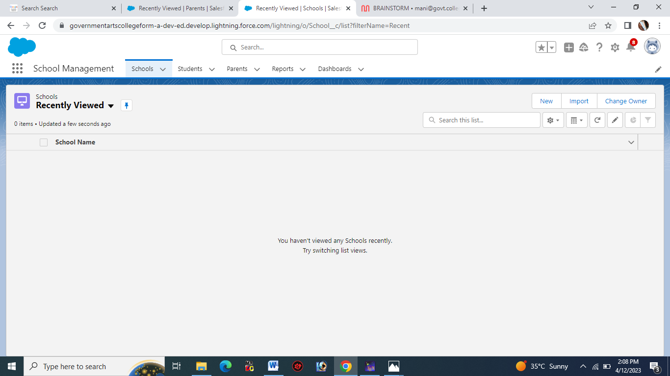

- Milestone-4: Fields And Relationship
School Fields And Relationship
- 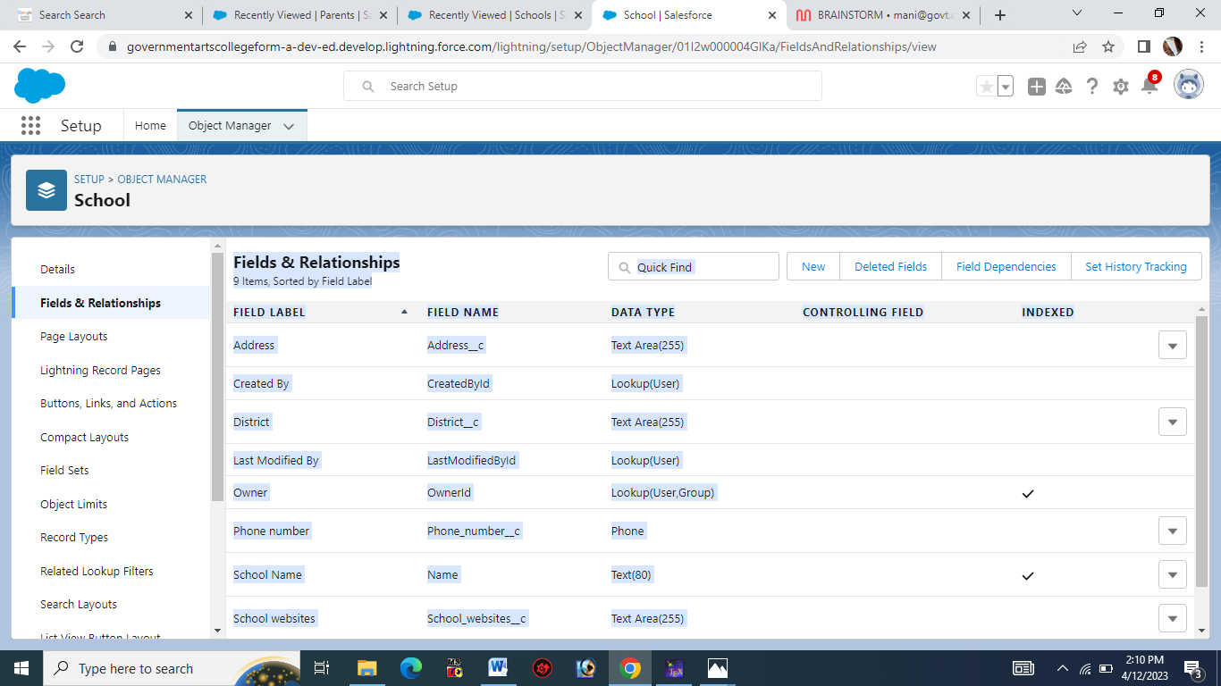

Student Fields And Relationship
- 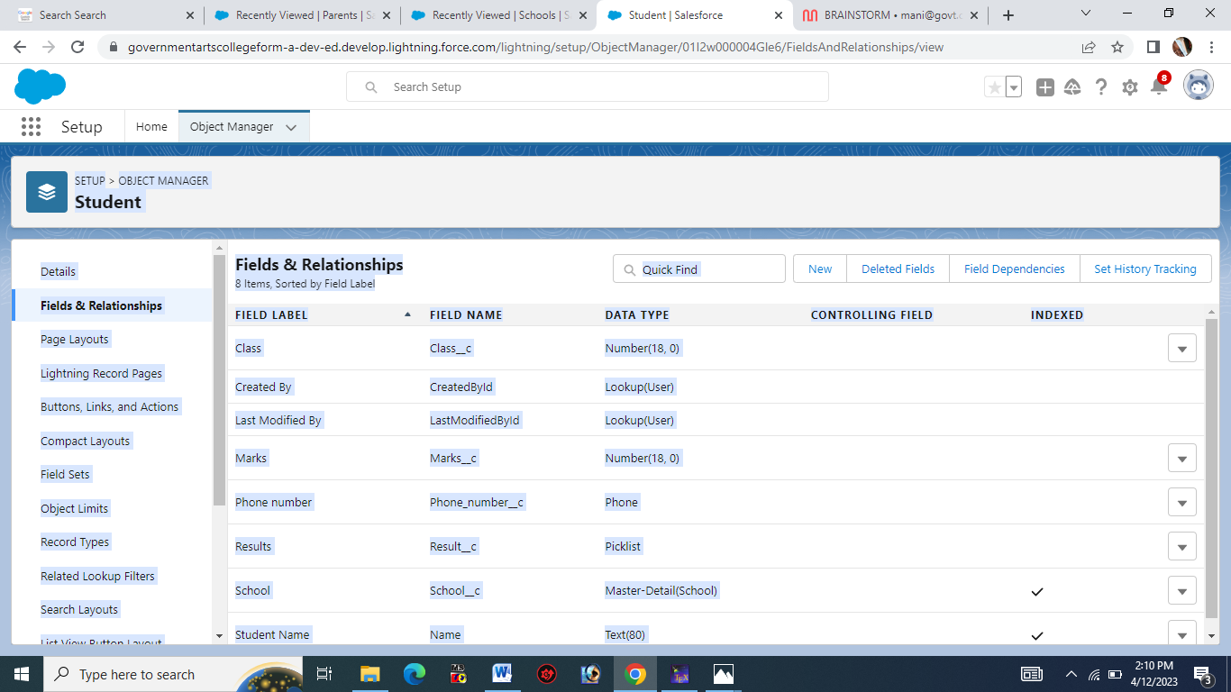
Parent Fields And Relationship
- 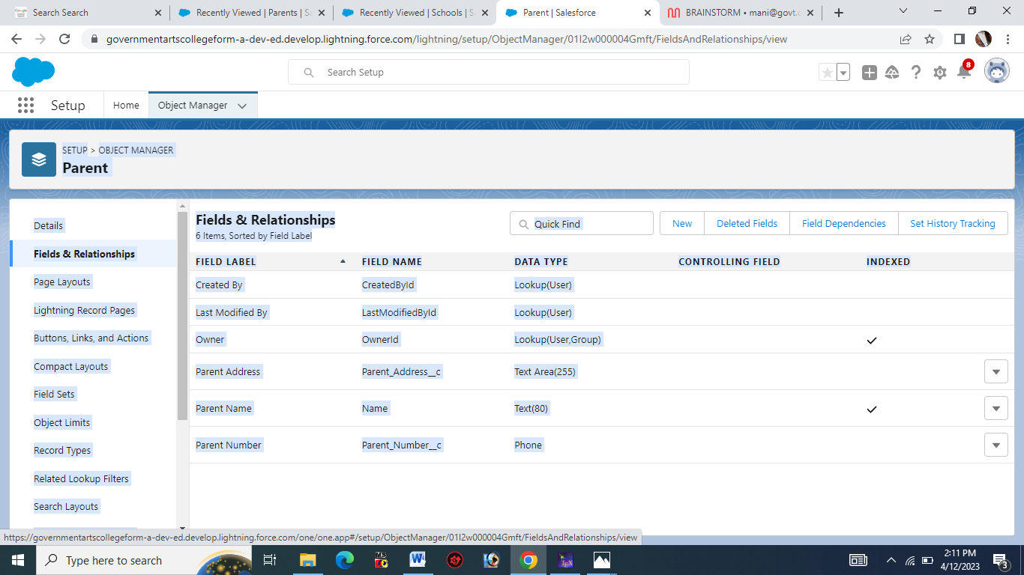

Milestone-5: Profile
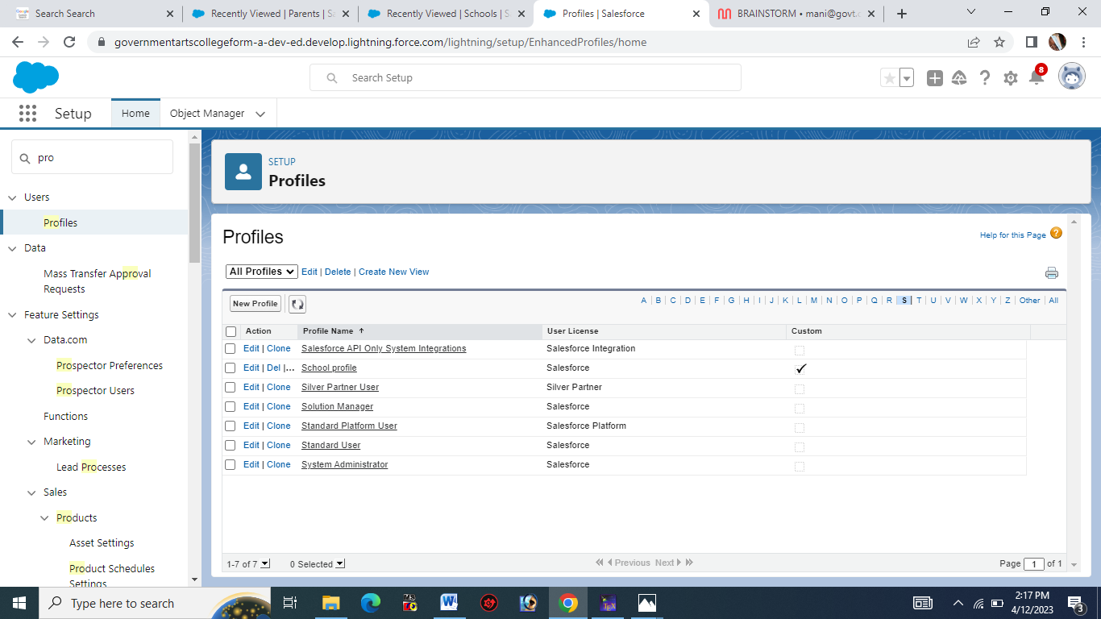

Milestone-6:Users
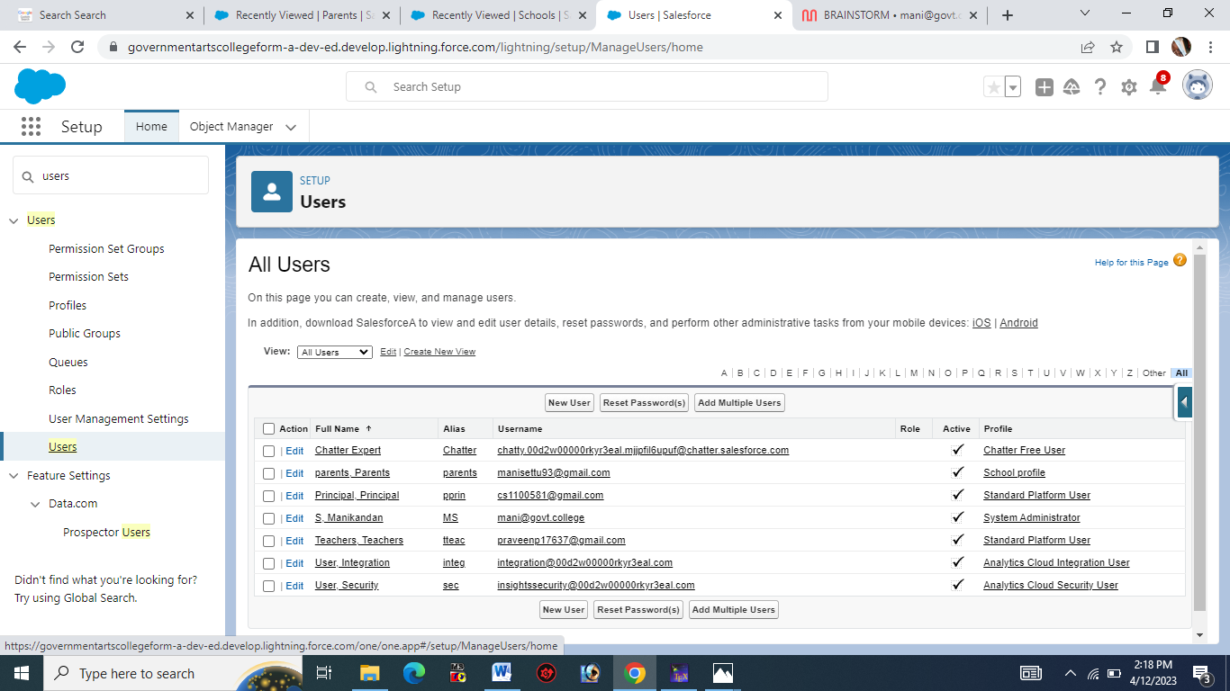

Milestone-7:Permission Sets
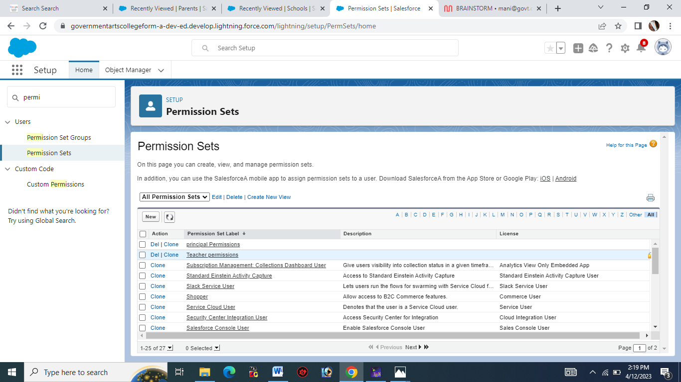
Milestone-8
: Reports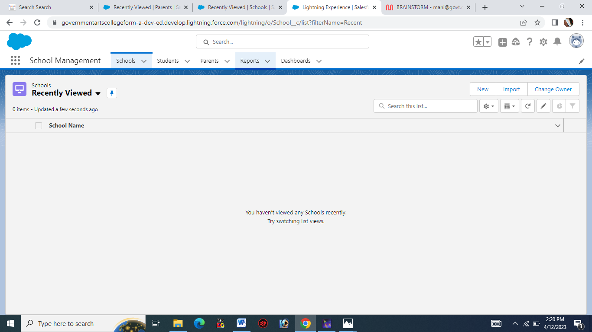

Trailhead Profile Public URL

Team Lead - https://trailblazer.me/id/manis1335 Team Member 1 - https://trailblazer.me/id/kavisk

Team Member 2 - https://trailblazer.me/id/kubet1
Team Member 3 –
https://trailblazer.me/id/ppraveen88

Project Report Template

- ADVANTAGES & DISADVANTAGE
ADVANTAGES:

              - It makes the management as very simply
              - It will helps us to create a bonding between Parents and Teachers
              - School and Teachers
              - Efficiently

DISADVANTAGES:
              - It will make man lasy
              - If small error will make big problem
              - costly

- APPLICATIONS

- This Project will use in School Management
- Also use in college
- It will make our work easily
- Complicated work are made within few steps

- CONCLUSION

The Project is very useful for school and collges.
CRM –means Customer Relationship Management
It makes the management as very easy

- FUTURE SCOPE

- In future it will occupie every where.
- It play major role in future

